Proposed Agenda
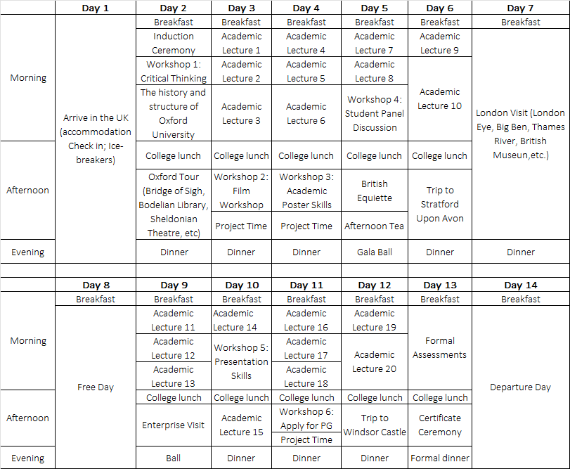
Proposed timetable subject to minor changes.

