Q&A
- Application processes and timeline
Peabody Application checklist: https://peabody.vanderbilt.edu/how-to-apply/
*If a student is nominated by BNU, there is no need for recommendation letters.
- Nominated students should apply to Peabody programs through the application portal by January 3rd of their junior year.
- VU will deliver the admission decision by mid-February.
- Students will accept offers by April 15 to prepare for enrollment and immigration processes, arriving on campus in August.
- Immigration-related information
PISA works closely with International Student and Scholar Services (ISSS) to support the immigration processes for our incoming international students.
- Peabody College Admission Webinar in Fall 2023
Peabody Fall Webinar calendar can be accessed from here: https://apply.vanderbilt.edu/portal/pbdy_events
- Costs
The cost for graduate students includes two parts, direct and indirect:
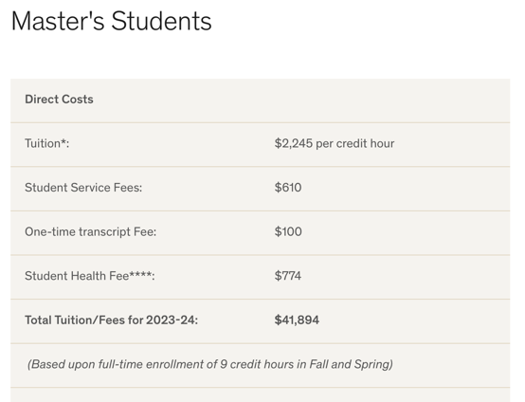
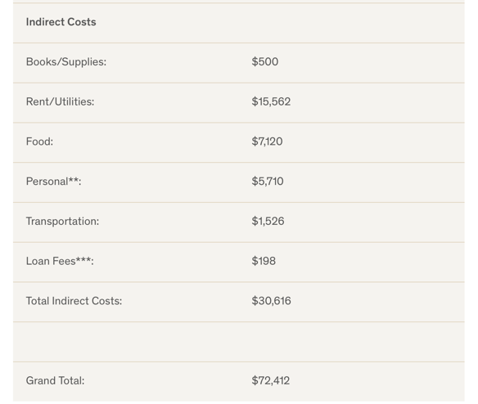
There might be about a 5% increase in the tuition for 2024-2025.
The expenses under “Indirect Costs” might be significantly lower depending on the living arrangements, transportation needs, etc. For example, by having roommates, using public transportation, and purchasing E-books and used books, students could save more.
- Will Peabody give help on finding accommodation on campus or off-campus?
Vanderbilt does not provide on-campus housing for professional and graduate students.
However, the Peabody International Students and Affairs (PISA) office is a part of the Peabody Enrollment transition team, we will facilitate the summer transition sessions to highlight the housing resources available in Nashville. PISA also has a specific program, iMAP, to provide mentorship and friendship for incoming students. We always have Chinese iMAP mentors who are willing to connect with incoming students in looking for accommodations, airport pickups, and grocery shopping.
Vanderbilt Chinese students also use the network of the Chinese Students and Scholars Association to help find local housing: https://anchorlink.vanderbilt.edu/organization/vucssa

