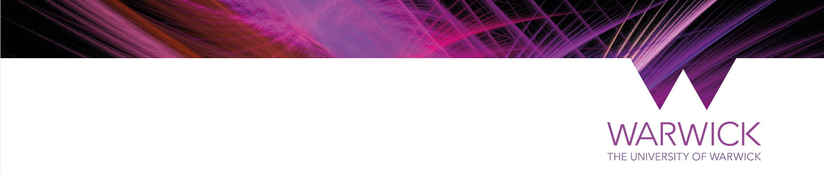

**Warwick Summer School 2025**   
**Beijing Normal University Group Booking**

We look forward to welcoming you to the University of Warwick this summer. Please follow the steps below to create your application for Warwick Summer School 2025.

**Making your application**

* When you are ready to apply, please visit the application form here: <https://your.warwick.ac.uk/form/warwicksummerschoolgroup>
* You will be asked for some personal details and any special requirements you may have.
* You will then need to complete your education details for your current course of study. **When asked to select your university, please select Beijing Normal University**
* The next section will ask for your course choice. Please make sure you meet the entry requirements for your chosen course. You can view a full list of our courses and their entry requirements on our webpages here: <https://warwick.ac.uk/study/summer-with-warwick/warwick-summer-school/courses/>
* Please select the option ‘yes- I am part of a group booking’ when asked ‘are you applying as part of a group?’ and **enter the discount code: BNU2025**
* **Please make sure you tick the box ‘I’m happy to receive email updates about my application to Warwick’ as otherwise we are unable to send your offer email.**
* You will need to pay £1000 deposit by **31st March 2025** to secure your place on the programme once you have received an offer.

**Documents**

* Once you have completed your application form, you will receive an application acknowledgment email.
* The email will have a link to upload your supporting documents- please upload your supporting documents as soon as you can after you have applied. You will need to upload:
  + A copy of the photo/data page of your passport.
  + A copy of your transcript, or a screenshot of your online student portal, which shows your name, the name of your university and a list of modules you are taking.

**After you have applied**

* Once you have applied, we will process your application.
* If you have not uploaded your documents, we will send an email confirming which documents you are missing.
* If your application is complete and you meet the entry criteria, we will be able to issue an offer email with instructions of how to pay your tuition fee deposit.
* Once the deposit deadline has passed, (31st March 2025) we know how many students are joining the programme from your institution, so we will be able to confirm the level of discount you will be eligible for. We will write to you at the beginning of April to confirm the final balance and with instructions on how to pay.
* Your final balance must be paid before 31st May 2025.

**Accommodation**

* Accommodation applications will open in May, and we will send you an email once applications are open.
* We have a range of accommodation packages on offer to suit various budgets; you can view our different accommodation options on our webpages here: <https://warwick.ac.uk/study/summer-with-warwick/warwick-summer-school/accommodation/>
* We strongly recommend you have any visas in place before paying for your accommodation
* If you wish to be placed in a flat with friends please request this at the time of booking.

**Visa and Electronic Travel Authorisation Information**

* You will be informed on your offer email if you require a visa, or directed to the UK Government website to ascertain whether you need an Electronic Travel Authorisation to travel for the Summer School; further details about this can be found on the link below.
* Once you have completed your tuition fee deposit payment, we will be able to send you a visa support letter that you can use to apply for your visa.
* If you require a visa, you will need to apply for a Standard Visitor Visa, and **you cannot apply for your visa more than 3 months before you intend to travel.**
* If you require an Electronic Travel Authorisation, you will need to apply for this individually before you travel to the UK. It usually take 3 days to be issued with an Electronic Travel Authorisation which is attached to your passport. The Electronic Travel Authorisation lasts for 2 years from date of issue and you are able to travel to the UK as many times as you want during that time.
* You can find further information about visas on our webpages here: <https://warwick.ac.uk/study/summer-with-warwick/warwick-summer-school/admissions/visa>

**Onboarding**

* Once you have paid a deposit, you will receive the first onboarding forms to complete.
* You will receive further onboarding forms in March.
* Information such as your timetable and resource pages will be sent two weeks before the start of the programme.